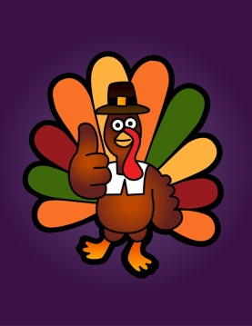
Reading Prompts
for November

- Where does the story take place? Discuss the important settings and explain why you believe each is important to the story.

- Describe a conflict between two characters. How was it resolved? What did you learn about these characters as they worked, or not, toward resolution of the conflict?

- Would you like to live in the book’s community? Are there advantages or disadvantages? Offer reasons from the text for your decision.

- What is the genre of your book? Giver examples that support your decision.

- What words does the author use that you might want to use in your own writing? How important are these words to the telling of the tale?

